NAME : S SUREDER
Set 2 (Sets 14-17) - Page 1

REG NO:1924260070

Set 16: Customer Demographics Analysis
Data Visualization using R

Aim
To analyse customer demographics using a bar chart, a pie chart, a table and a dashboard in R.

Procedure
- Open RStudio and load the packages ggplot2 and gridExtra (install them once with install.packages(c("ggplot2", "gridExtra"))).
- Create the customer data as a data frame and group ages with cut().
- Question 1: draw the age bar chart with geom_bar().
- Question 2: draw the gender pie chart with geom_col() and coord_polar("y").
- Question 3: make the table with tableGrob().
- Question 4: join the charts and the table into a dashboard with arrangeGrob().
- Run the code and note the output and the figures.

R Code
library(ggplot2); library(gridExtra)

# Dataset
cust <- data.frame(Customer_ID = 1:3, Age = c(28, 35, 42),
Gender = c("Female","Male","Female"), Income = c(50000, 60000, 75000))
print(cust)
cust$Age_Group <- cut(cust$Age, c(20, 30, 40, 50), right = FALSE, labels = c("20-29","30-39","40-49"))
gender <- as.data.frame(table(cust$Gender)); names(gender) <- c("Gender", "Count") print(gender)

# 1. Bar chart - age distribution
p1 <- ggplot(cust, aes(Age_Group)) + geom_bar(fill = "steelblue") +
labs(title = "Customer Age Distribution", x = "Age Group", y = "Customers")

# 2. Pie chart - gender
p2 <- ggplot(gender, aes("", Count, fill = Gender)) + geom_col() + coord_polar("y") + geom_text(aes(label = Count), position = position_stack(vjust = 0.5)) +
labs(title = "Customers by Gender") + theme_void()

# 3. Table
tb <- tableGrob(cust[, 1:4], rows = NULL)

# 4. Dashboard
dash <- arrangeGrob(p1, p2, tb, layout_matrix = rbind(c(1,2), c(3,3)), top = "Customer Dashboard")

ggsave("set16_q1.png", p1, width = 6, height = 4, bg = "white") ggsave("set16_q2.png", p2, width = 6, height = 4, bg = "white")
ggsave("set16_q3.png", arrangeGrob(tb, top = "Customer Demographics Table"), width = 5, height = 2, bg = "white") ggsave("set16_q4.png", dash, width = 12, height = 8, bg = "white")

Output
Customer_ID Age Gender Income
1 1 28 Female 50000
2 2 35 Male 60000
3 3 42 Female 75000 Gender Count
- Female 2
- Male 1

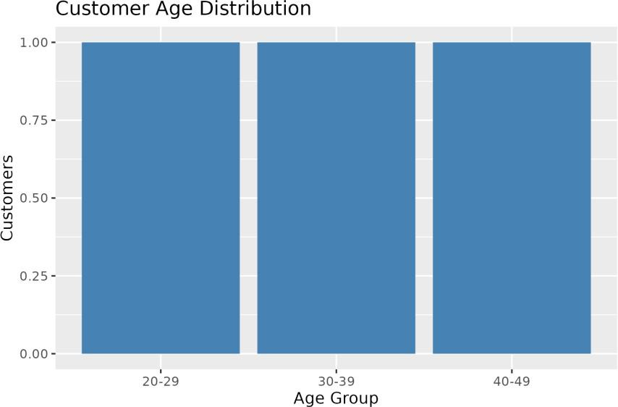

Figure 16.1: Q1 - Age distribution bar chart
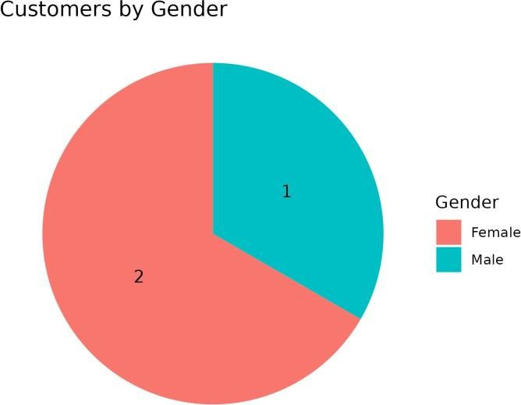

Figure 16.2: Q2 - Gender pie chart
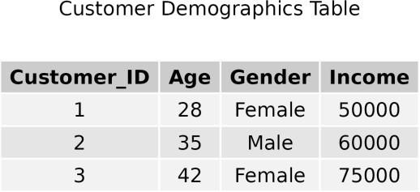

Figure 16.3: Q3 - Customer table

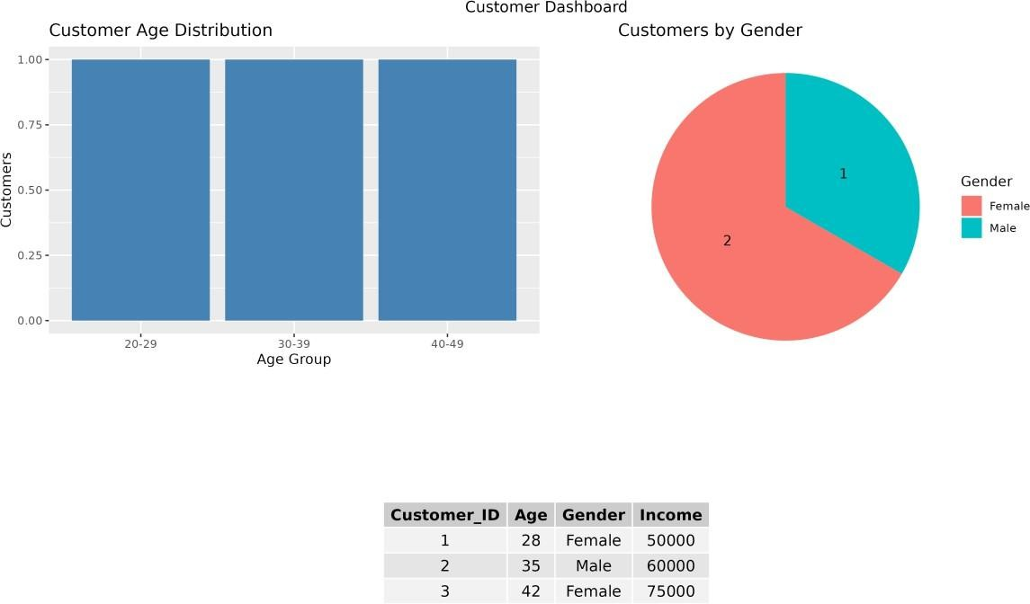

Figure 16.4: Q4 - Dashboard

Result
  - There is one customer in each age group (20-29, 30-39, 40-49).
  - Two customers are female and one is male.
  - All four parts were completed successfully in R.

